UPS – Setup Export Map

Setup Mapped Drive
Map M: drive to \\RAUSMSRV0002.RA.BG1857.NET\asr\UPS
To make sure this gets mapped for all users, create a map_drives.bat file and save to the following startup folder (Windows 11):
C:\ProgramData\Microsoft\Windows\Start Menu\Programs\Startup
Map_drives.bat:
@echo off
set attempt=1
:retry
net use M: \\RAUSMSRV0002.RA.BG1857.NET\asr\UPS /persistent:no
if errorlevel 1 (
if %attempt% leq 5 (
echo Attempt %attempt% failed. Retrying in 5 seconds...
set /a attempt=%attempt%+1
timeout /t 5 /nobreak > nul
goto retry
) else (
echo Failed to map drive M: after 5 attempts.
)
) else (
echo Drive M: mapped successfully.
)

Setup WorldShip Export
In UPS WorldShip Click on ‘Import-Export’
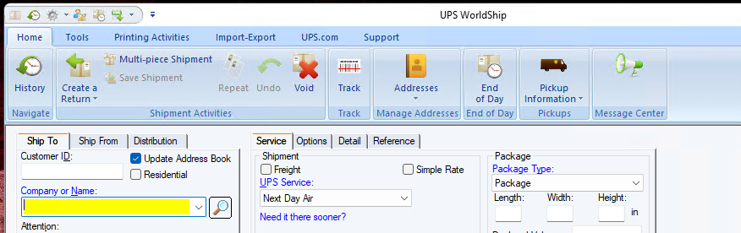

Under ‘Automatic Export’ > Export After Shipment Processing > More…
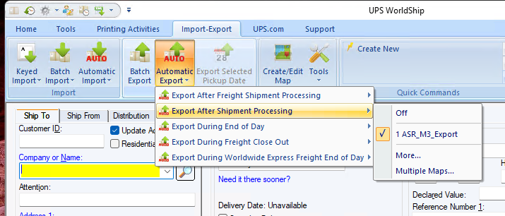
Select ‘Create / Edit Map’
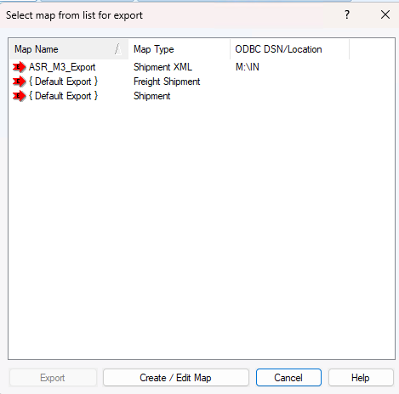

Select ‘Export to XML’ and select the default ‘Shipment XML’ Map Type. Enter the name, ‘ASR_M3_Export’ in this case.
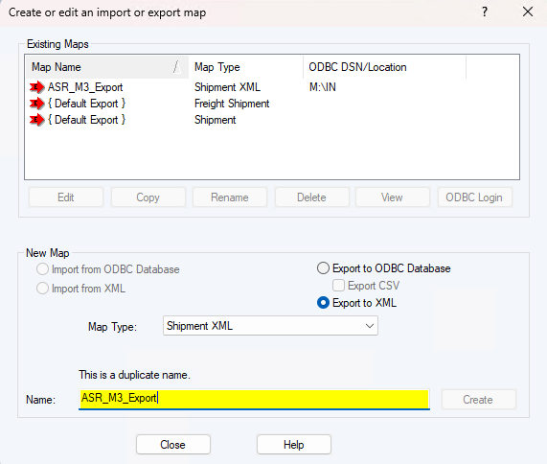
Click ‘Create’ and you will be prompted for the file location. Select the ‘M:\IN\’ folder setup in the first steps.
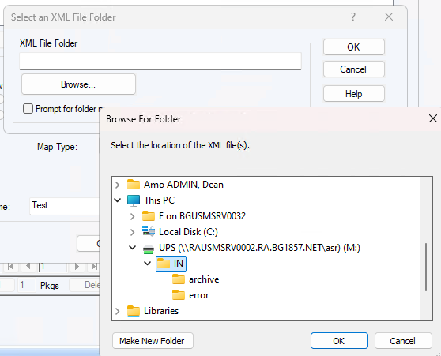

Setup WorldShip Import
Create a 32-bit ODBC DSN to the M3 ERP Azure Replica Database Server. Open ‘ODBC Data Source Administrator (32-bit)’ and click ‘Add…’
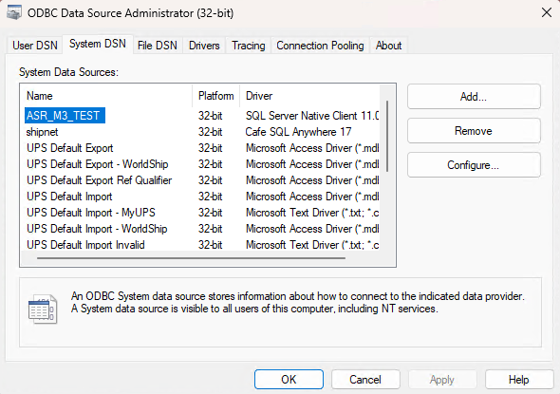
Select the appropriate SQL Server driver and click ‘Finish’
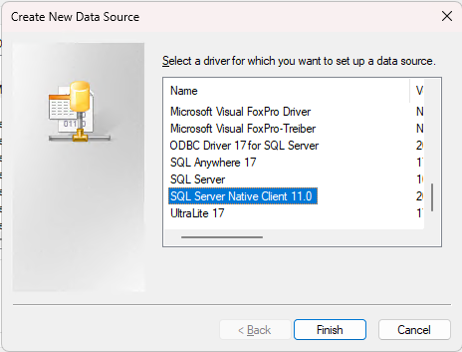
Fill in the name and the server, then click ‘Next >’
For ASR M3 the servers are:
TEST:
ngeumsmi0001.382a44b6e9bc.database.windows.net
User: SM0004
Password: <Ask Development Team for Password – in Key Vault>
PRODUCTION:
ngeumsmi0002.d44d2f32ac81.database.windows.net
User: SM0004
Password: <Ask Development Team for Password – in Key Vault>

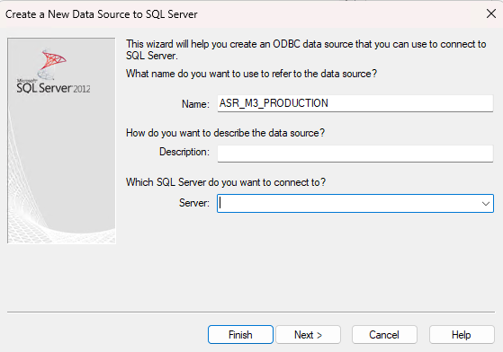
Pick ‘With SQL Server authentication’ and enter the user & password for the environment you are connecting to, click ‘Next >’
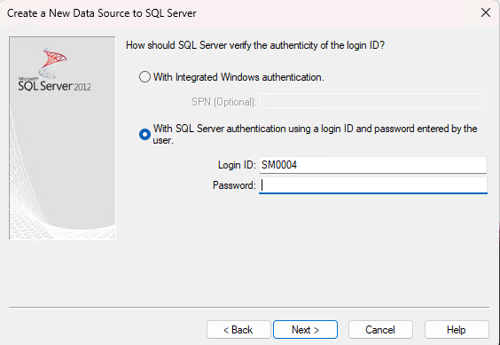

In UPS WorldShip Click on ‘Import-Export’
Go to Keyed Import > More…
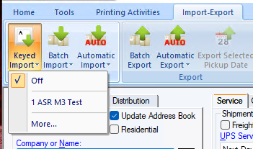
Select ‘Create / Edit Map’
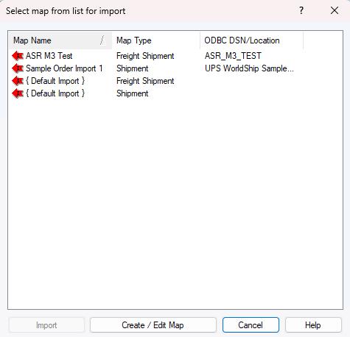

Make sure ‘Import from ODBC Database’ is selected and type the Name: and hit ‘Create’
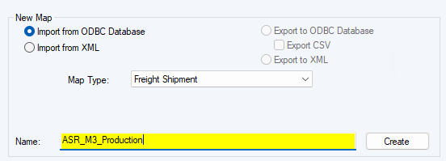
Select the ODBC data source you created in the prior step and re-enter the credentials;
User: SM0004
Password: <Ask Development Team for Password – in Key Vault>
Click ‘OK’
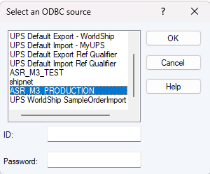
Select vw_fedex_ups_address_query
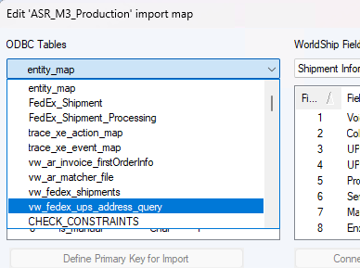
IMPORTANT
Click on ‘delivery_number’ and click ‘Define Primary Key for Import’

Click on each field and create the following mappings. Click on the ‘ODBC Tables’ field and then the ‘WorldShip Fields’ field and click ‘Connect’.
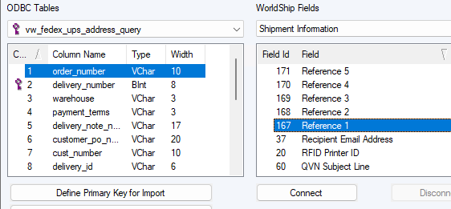

For all of the following;
ODBC Tables (vw_fedex_ups_address_query) | WorldShip Fields
telep | Ship To: Telephone
state | Ship To: State/Province/Country
ship_to_country | Ship To: Country / Territory
postal code | Ship To: Postal Code
order number | Shipment Information: Reference 1
notification_email | Ship To: Email Address
delivery _number | Shipment Information: Reference 5
customer_po_number | Shipment Information: Reference 2
company_name | Ship To: Company or Name
city | Ship To: City or Town
address_line_3 <Don’t map, has city/state zip for US> | Ship To: Address 3
address_line_2 | Ship To: Address 2
address_line_1 | Ship To: Address 1

Close until you get to this screen, then select your new Map and click ‘Import’
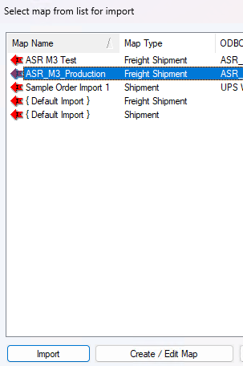
Now your new map will be available for use from the menu;

